# CS 255 System Design Document Template

## UML Diagrams

### UML Use Case Diagram

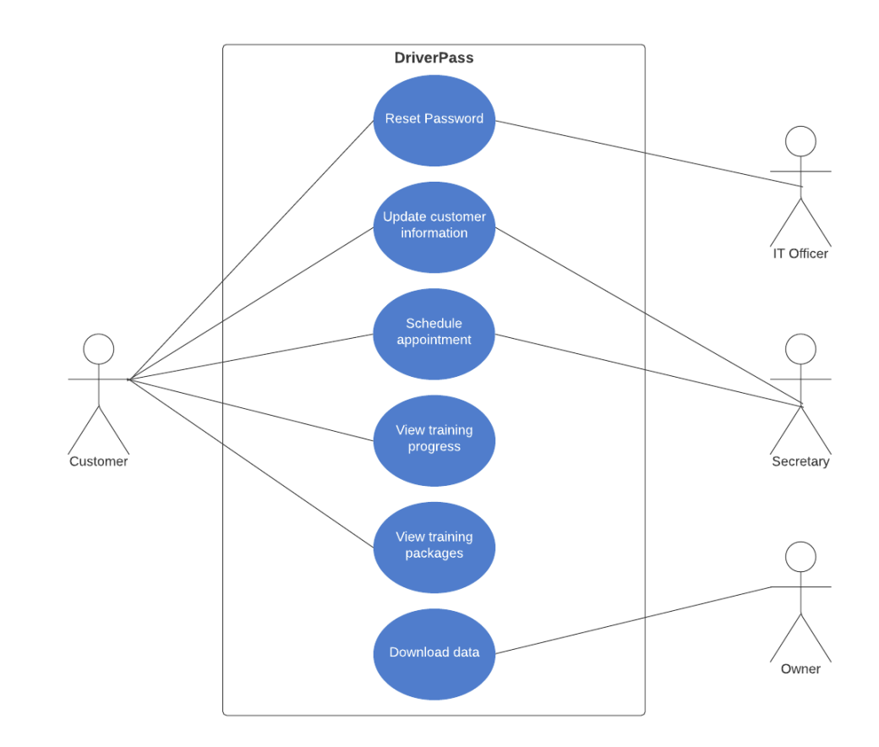

### UML Activity Diagrams

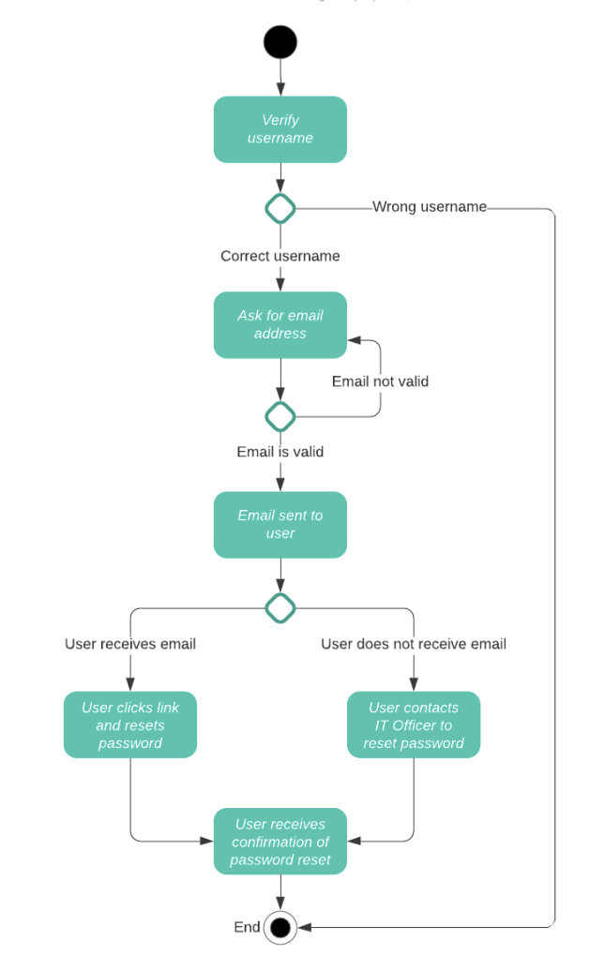

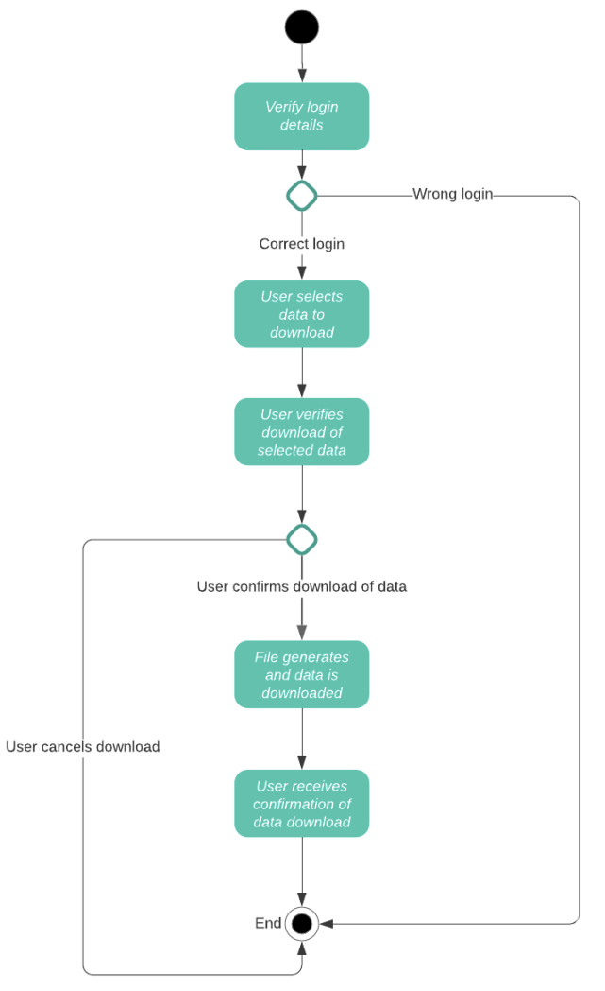

### UML Sequence Diagram

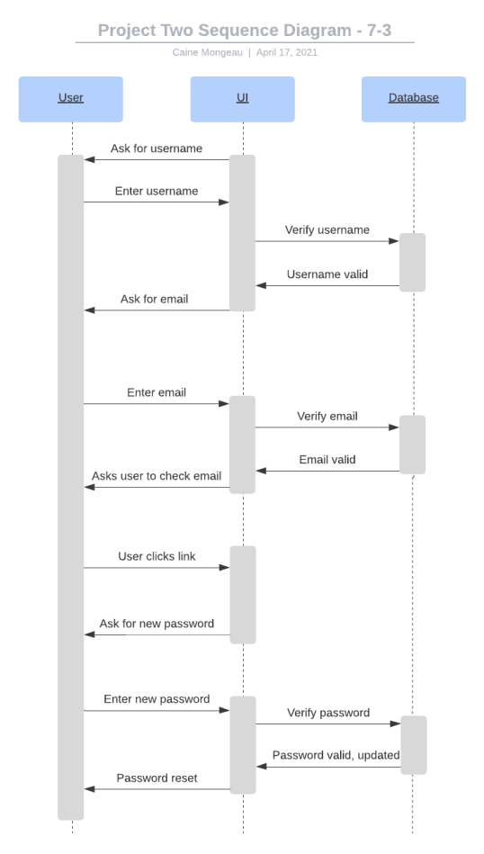

### UML Class Diagram

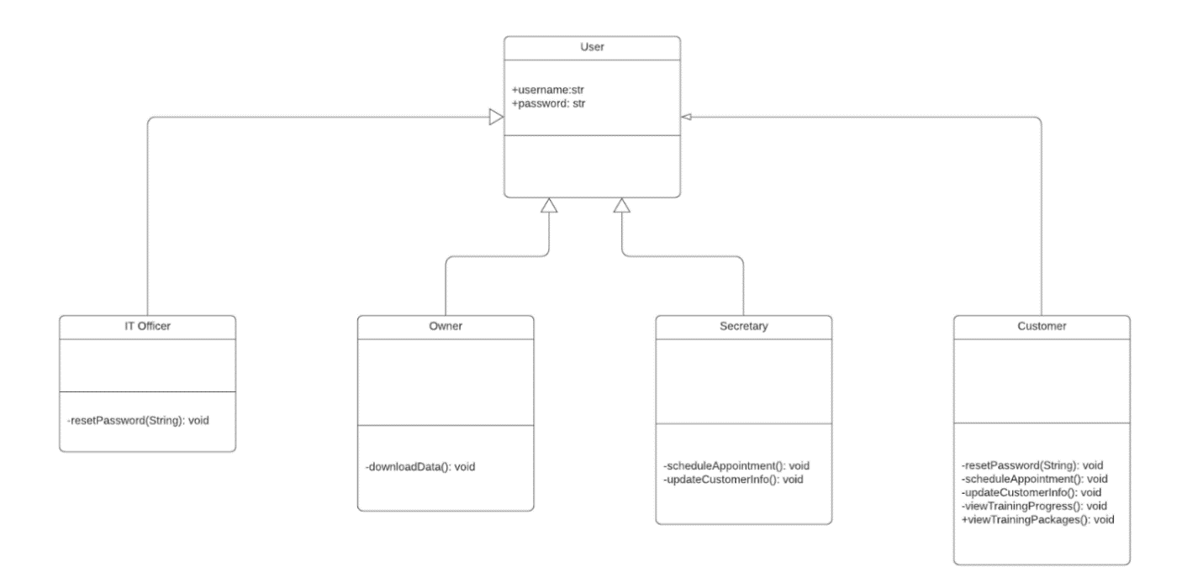

## Technical Requirements

The system that was created is technical, but will mainly operate from the cloud. Using the cloud, there will be a mobile version created for the owner to have access on the move. A database will be needed, and this database could either be cloud based on in a data center. This database will store vital and personal information and keep it safe. SSL will be used to encrypt our data at every endpoint, starting with interactions between users and the system. By opting for the cloud based route, information will process faster, update faster, and track progress faster. The system will also track the calendar and scheduling, as well as the user’s progress. Lastly, we will add roles into the system that will allow the owner, IT, and other elevated users access to more features and able to edit more things. Updates will be pushed from the cloud and maintained by IT.